

CS 319-Object-Oriented Software Engineering

Project Report

Royal Road

Group 17

Kadir Ata Dönmez

Veysel Alperen Ceylan

Yakup Kılıç

Table of Contents

[1 Introduction: 3](#_Toc470378850)

[2 System Requirements and Installations: 3](#_Toc470378851)

[2.1 System Requirements: 3](#_Toc470378852)

[3 Playing the Game: 3](#_Toc470378853)

[3.1 Overview of the Game: 3](#_Toc470378854)

[3.2 Enemies: 3](#_Toc470378855)

[3.3 Objects 4](#_Toc470378856)

[3.4 Health: 5](#_Toc470378857)

[3.5 Controller: 5](#_Toc470378858)

[4 Game Screenshots & Menus: 6](#_Toc470378859)

[4.1 Menu: 6](#_Toc470378860)

[4.2 Instructions: 6](#_Toc470378861)

[4.3 Bestiary: 8](#_Toc470378862)

[4.4 Credits: 9](#_Toc470378863)

[4.5 Start Game and Scenario Page: 10](#_Toc470378864)

[4.6 Game Screen: 11](#_Toc470378865)

[4.7 Pause Mod: 12](#_Toc470378866)

[4.8 Win and Lose Dialogue Pages: 13](#_Toc470378867)

# 1 Introduction:

Royal Road is purely Java based adventure game and the basic fundamentals of the game like movement, level exploration and action will be inspired from Hotline Miami, such as UI design, playability and art style.

**Hotline Miami link:**

http://store.steampowered.com/agecheck/app/219150/?l=turkish

Primary aim of this game will be heavily on Player-to-Object and Object-to-Object interactions like killing creatures by shooting bullet at them, passing corridors and collecting items and such.

# 2 System Requirements and Installations:

## 2.1 System Requirements:

The Standard Java Runtime Environment (JRE) must be installed before installing the game. To download: <https://www.java.com/tr/download/>

**2.2 Installations:**

Unzip the “royal road.zip” to a directory on your computer and to run the game you have 2 choices.

1- Run the “royal road.jar” to execute the game (which it is recommended)

2- If you have knowledge of java programming, by running our code in java and can play the game.

# 3 Playing the Game:

## 3.1 Overview of the Game:

The player controls a single character to explore rooms and corridors that are filled with creatures and dangerous traps. The player will be able to move freely all directions except corridor lines and map borders. Shooting capability is at the direction that only looking way. There will be many items that will upgrade and enhance player’s abilities. These abilities may be temporary or permanent. Some creatures/enemies would be coded behavior; some of them would have basic AI. There would be two type of objects that are independent and dependent.

## 3.2 Enemies:

Enemies will have two different types of behavior set to them: melee and ranged. Melee attacks when it closes to player and ranged shots from range. They also can patrol in certain areas or coming closer when they see the player.

C:\Users\USER\AppData\Local\Microsoft\Windows\INetCache\Content.Word\homeless.png C:\Users\USER\AppData\Local\Microsoft\Windows\INetCache\Content.Word\ninja.png C:\Users\USER\AppData\Local\Microsoft\Windows\INetCache\Content.Word\waylayer.png C:\Users\USER\AppData\Local\Microsoft\Windows\INetCache\Content.Word\pirate.png

Figure 1 – Homeless Figure 2 – Ninja Figure 3 – Waylayer Figure 4 - Pirate

1. Homeless: The weakest enemy. They are melee class enemy. They attack with punch and they take down player’s one health. They are patrolling in certain areas.

2. Ninja: Slightly stronger counterpart of Homeless, they can attack from range. They throw iron shurikens and they take down player’s one health. They can patrolling in certain areas or start shooting when they see the player.

3. Waylayer: This guy hits harder and he is harder to take down then the Ninja, but they attack slower than ninja. They attack with sword that takes down player’s two health, so they are melee class enemy. They are coming closer when they see the player.

4. Pirate: The hardest enemy in game. They use guns which take down player’s two health. They can patrol in certain areas or start shooting when they see the player.

## 3.3 Objects

Objects (Independent)

Independent objects execute their behavior with/without player’s intervention.

1. Fire Traps: When Player gets on it, his health decreases one. There are two types of fire traps.

C:\Users\USER\AppData\Local\Microsoft\Windows\INetCache\Content.Word\fire.png



Figure 5 – Fire Traps

Objects (Dependent)

Dependent objects, contrary to independent objects, will not execute their predetermined behavior unless player gives any kind of input to them. However, they are the only way to change the existing behavior of the independent objects as well.

1. Locked Door: If the player killed 2 enemies in the world, it will open, giving access to new room.

C:\Users\USER\AppData\Local\Microsoft\Windows\INetCache\Content.Word\locked door.png



Figure 6 – Opened and Locked door

Terrain

Terrain types are usually for determining the graphics that a tile will use, but some terrain might have special perks attached to them, the main example fire traps, which is still a walkable floor, but it will damage the players when walked on.

1. Floor: Standard terrain type with nothing special about it.

C:\Users\USER\AppData\Local\Microsoft\Windows\INetCache\Content.Word\grass.pngC:\Users\USER\AppData\Local\Microsoft\Windows\INetCache\Content.Word\desert.png

Figure 7 – Grass and desert floor

1. Wall: Standard impassable terrain.



Figure 8 - Wall 

## 3.4 Health:

User can see his remaining health at the right top corner of the game screen. Health will be different according to collision with the enemy’s bullets and themselves.



Figure 9 - Health

## 3.5 Controller:

To use player, users use arrow keys on their keyboard.

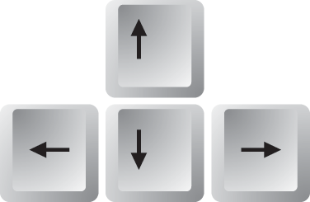

Figure 10 –Arrow Keys

C:\Users\USER\AppData\Local\Microsoft\Windows\INetCache\Content.Word\key_X.PNG To kill enemies, users use 'Z' and 'X' keys for different weapons on their keyboard to shoot.



Figure 11 – Z and X keys



Figure 12 – O and P keys

To pause game, users use 'P' key on their keyboard and use 'O' key to play again.

Also users can use their mouse to click buttons in the menu.

# 4 Game Screenshots:

## 4.1 Menu:

This game has a main menu including start game, instructions, bestiary and credits choices. Start game choice constructs a new game for the player. It starts a new game with scenarios.

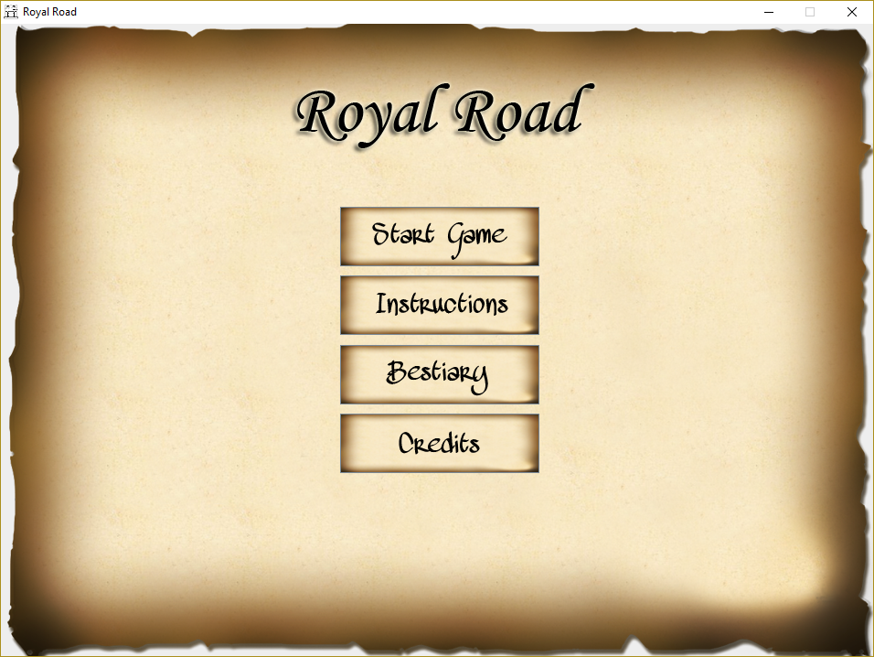

Figure 13 – Menu screen

## 4.2 Instructions:

In the instructions page users know how to play game with keyboard. And they can get back to menu again with back button.

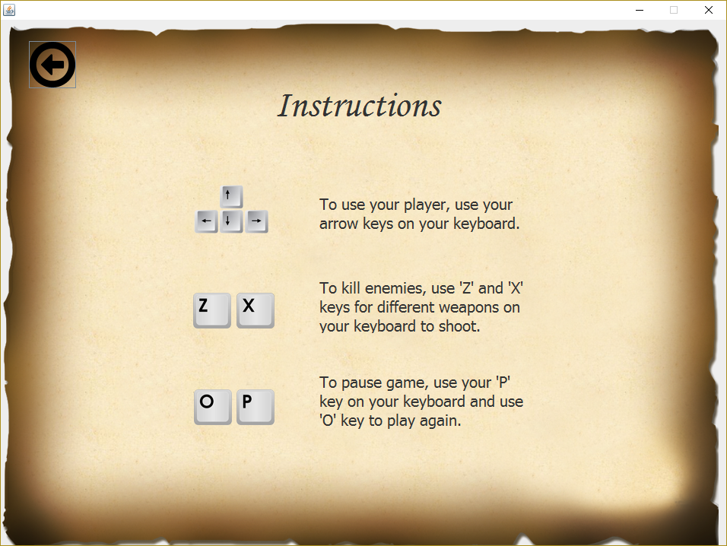

Figure 14 – Instructions Screen

## 4.3 Bestiary:

In the bestiary page users know enemies with their properties. And they can get back to menu again with back button.

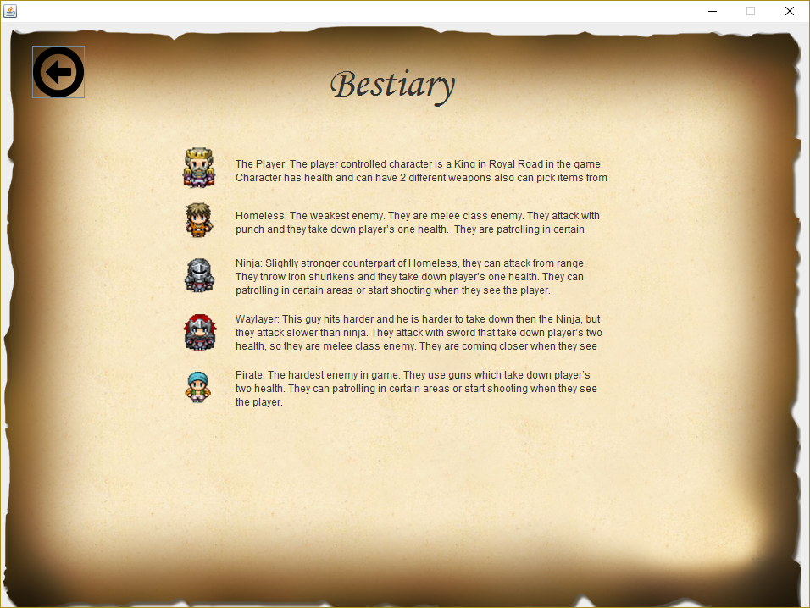

Figure 15 – Bestiary page

## 4.4 Credits:

In the credits page users know the creators of this game with dialogue screen.

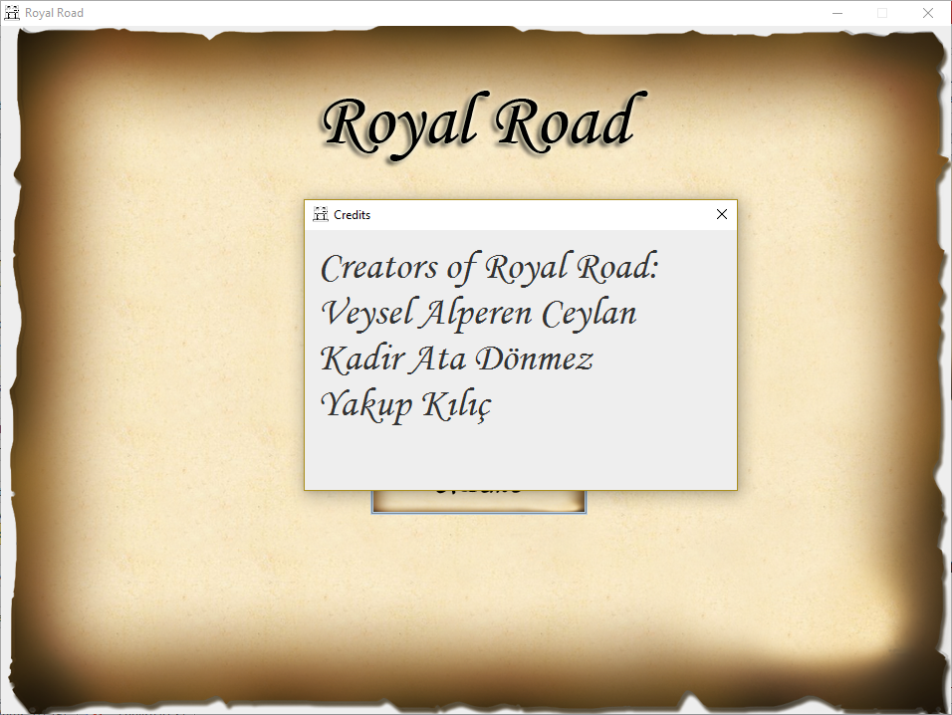

Figure 16 – Credits

## 4.5 Start Game and Scenario Page:

When users click start game button on the menu page scenario page opened to inform users to background story about game before the game start. Users can get back to menu with back button and start the game with Start Journey button.

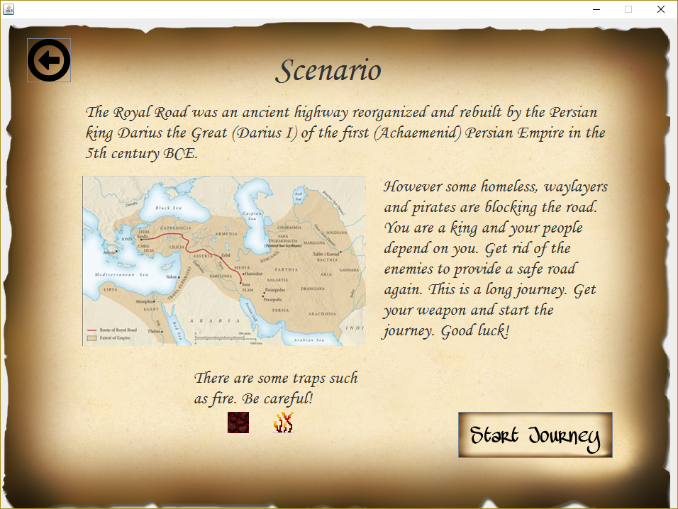

Figure 17 – Scenario

## 4.6 Game Screen:

These pages are the pages that users play in.

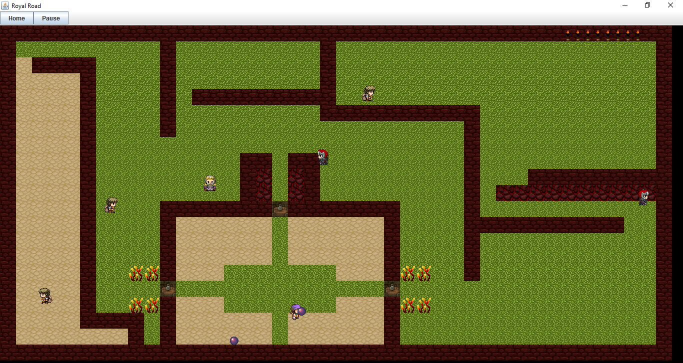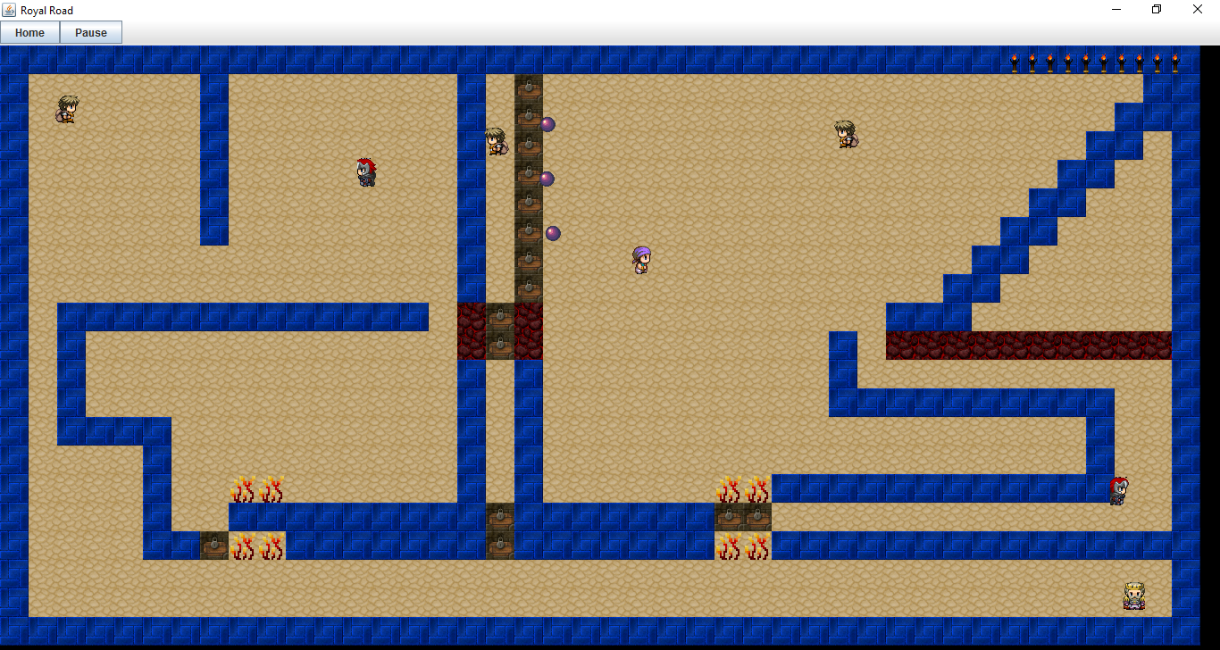

Figure 18 – Game Screens that belong to different levels.

## 4.7 Pause Mod:

When users press “p” key on their keyboard or click Pause button from the top left corner, game is paused and everything stopped until users press “o” key on their keyboard or click Continue button from the top left corner.

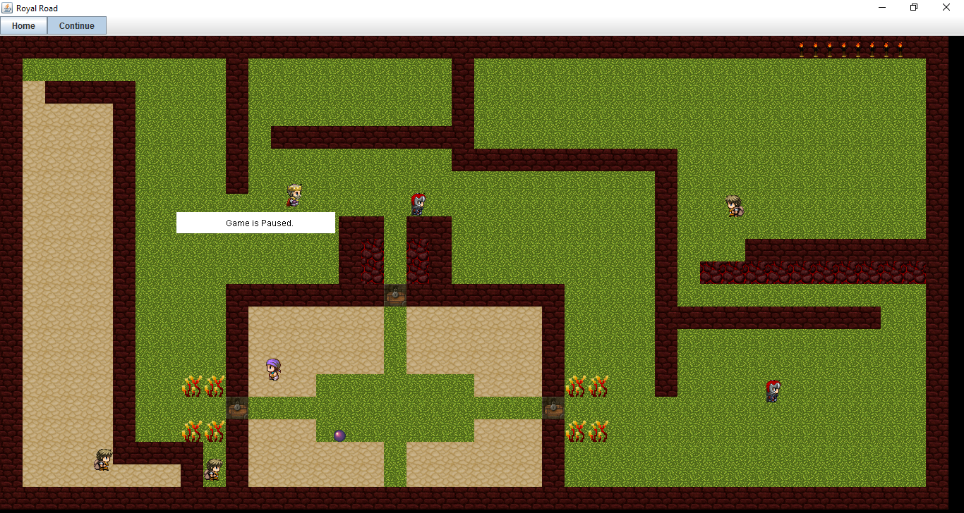

Figure 19 – Pause mod screen

Also when users click the Home button from the top left corner, the pup op dialogue shows and game automatically paused and if the users click the OK button game will close and menu page open. Otherwise, game will continue.

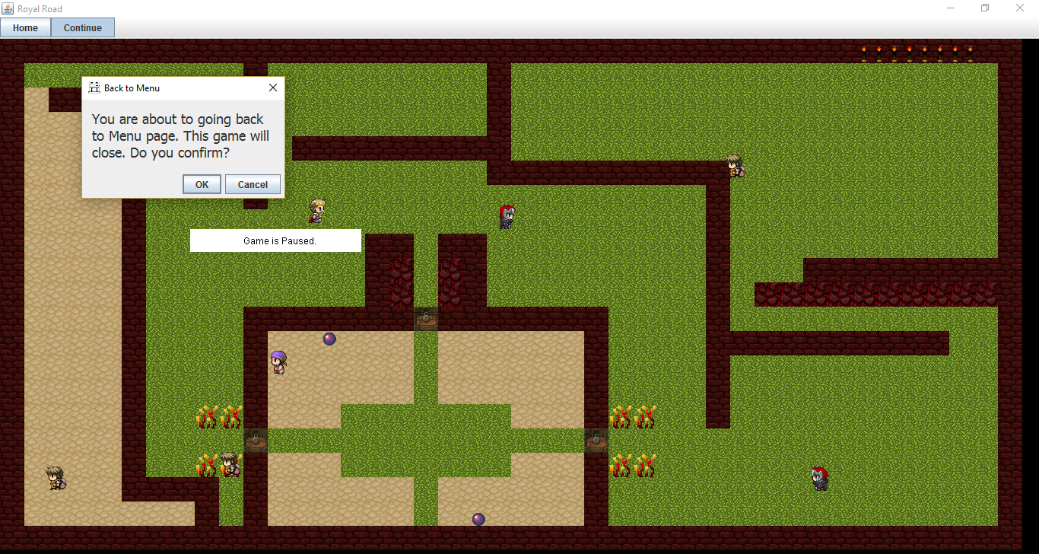

Figure 20 – Pause mod screen with dialogue message from Home button.

## 4.8 Win and Lose Dialogue Pages:

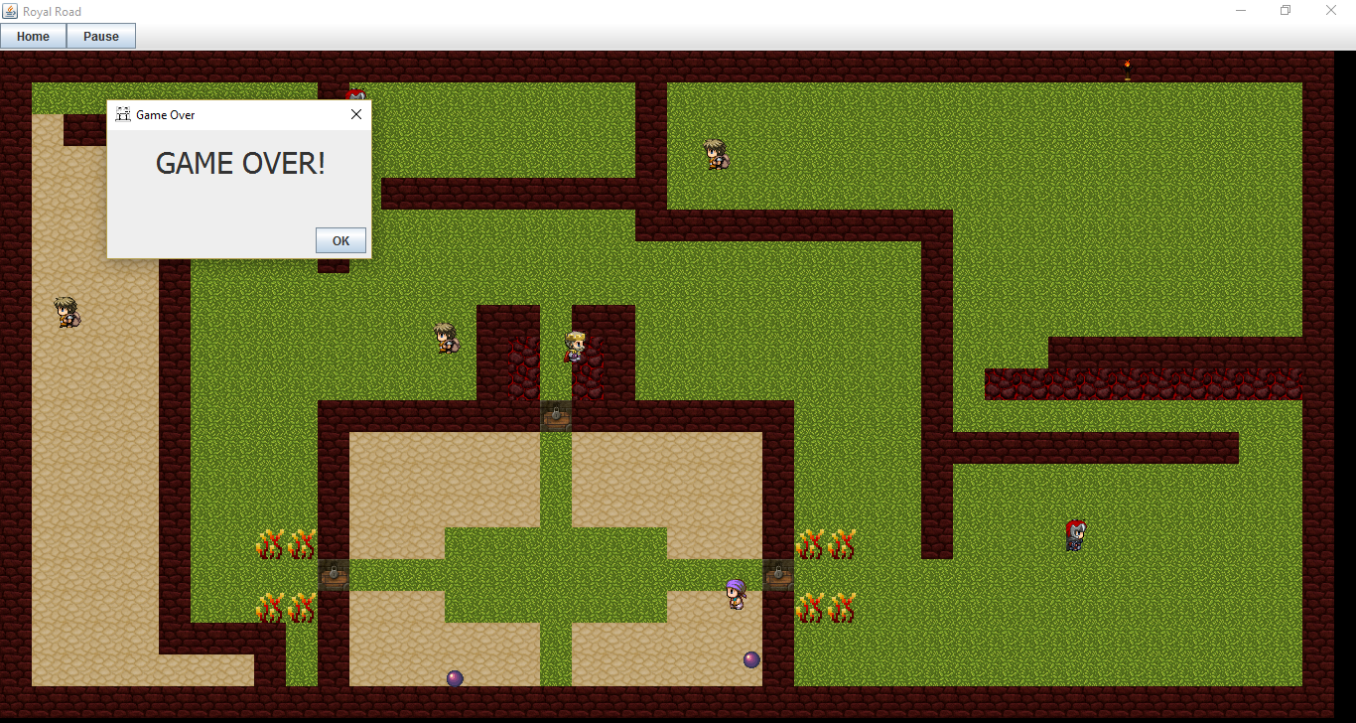

Figure 21 – The game screen with pop op message about Game Over because of the player is dead.

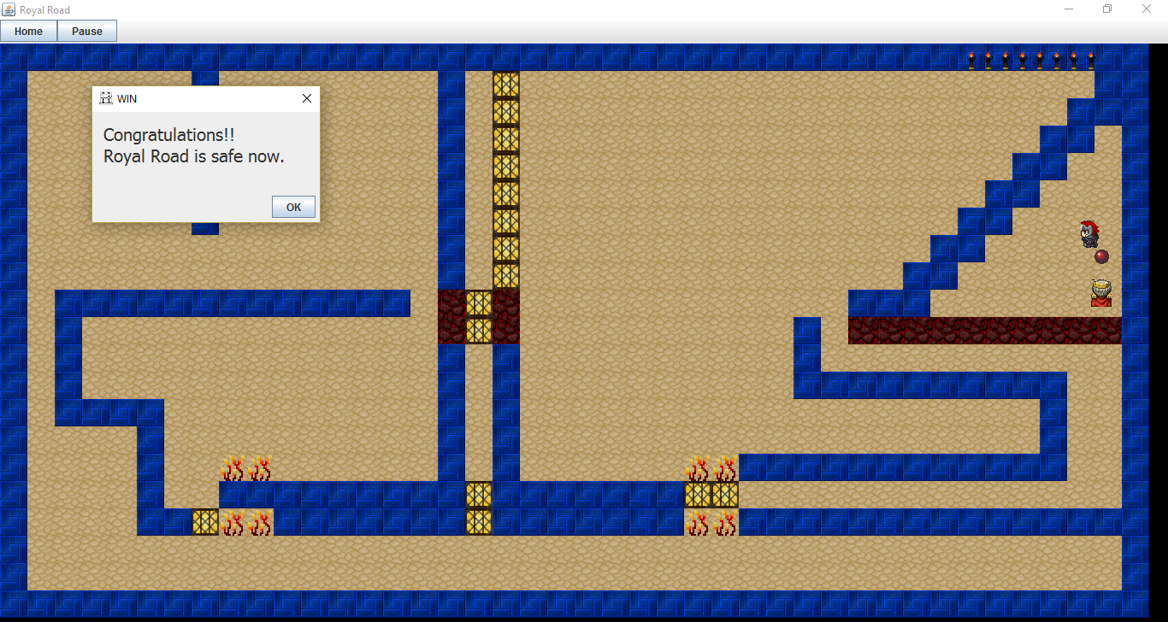

Figure 22- The game screen with pop up message about the player finished the game.